### MINI PROJECT

### (2019-2020)

## Build and Deploy an Android Application for Conducting

## Online Quizes.

## MID-TERM REPORT



## Institute of Engineering & Technology

## Submitted by-

## Ritesh Dwivedi

## (181500573)

## *Supervised by-*

## **Mr. Anand Gupta**

## Technical Trainer

## Department of Computer Engineering & Application

### Contents

### Abstract

### Introduction

General Introduction to the topics

Area of Computer Science

Hardware and Software Requirements

### Problem Definition

### Objectives

### Implementation Details

### Progress till Date & The Remaining work

### Some Screenshots

### References

### Department of Computer Science & Engineering

## Abstract

#### This work deals with development of android-based multiple-choice question examination system,namely:Quizify.This application is developed for educational purpose,allowing the users to prepare the multiple choice questions for different examinations conducted on provincial and national level. The main goal of the application is to enable user to practice for subjective tests conducted for admissions and recruitment,with focus on computer science field. This quiz application includes three main modules, namely Computer science, verbal, analytical. The computer science and verbal modules contain various types of sub categories. This quiz includes three function hint,skip,pause which are collectively named as life lines that help user to answer question correctly.These functions can be used only once by a user .It shows progress feedback during quiz play.and at the end, the app also show the result.

#### 

#### Department of Computer Science & Engineering

### Introduction

### General Introduction to the topic

### Here we shared an Android Application and it’s name is Quizify.Development of android-based Quiz application is mainly required by students and learner to prepare themselves for different examinations directly through smart phones and tablets in hands. One of the major goal of the project is to facilitate students in learning,gaining and improving their knowledge skills. At the meantime,our app provides them fun so that the users can prepare for interviews, entrance tests or any other corresponding purpose in a fresh mood and can’t get bored or frustrated due to dullness of app. We designed the application to facilitate the users to be able to take short quizzes using portable devices such as smart phones and tablets.As Android is rapidly famous day by day and the number of its users are increasing with every blink of eye because it is easy to access the necessary android based applications on smart phones and tablets in your hands.

### Therefore we find this idea interesting,easy and time efficient to facilitate the users in this way without any difficulty. There are many online quiz applications available on internet, but most of them are only for entertainment and fun, Moreover, if one is going to appear in any test or interview, then it is difficult and time consuming for them to read the full books or articles related to specific fields for the preparation or revising their knowledge.But the most attractive features of our app is that we take learning and fun side by side. Our app provides them the facility to revise their knowledge or to learn something advantageous at one place without wasting their time.

## Department of Computer Science & Engineering(CSE).

### Programming Language:

### Technology                                : Java, Kotlin

### Database                         : MySql5.0

### Hardware Requirements

### Memory[4GB RAM(or higher)]

### Intel core i3 64-bit Processor(or higher)

## Software Requirements

### Android Studio Code

### Operating System Windows 95 or 98, XP

### Department of Computer Science & Engineering

### Objective

The basic objective of this project is to develop an android-based system with following features,

namely: (i) Questions bank, (ii) Time frame, (iii) Life lines, (iv) Data Storage, and (v) Multimedia

support (pictures, snapshots, tables). The main objective to create this Quiz app is to help the users

for the preparation of necessary educational purposes regarding Computer Science and IT field

with an easy access to our app directly on their Android phones. Through our app, users can learn

and prepare themselves for interviews, tests and exams on Android phones, and can also use this

app for increasing their general knowledge about Computer Science, Verbal and Analytical

everywhere and anytime

It is essentially required to assist students for the learning and preparation of different tests

conducted for admission in higher studies. However, there exist no such application in

android-based platform, which can provide candidates with both preparation of such tests in

user friendly and interactive way. This is what we tried to address in the development of Quizify**:**

Quiz Application Development using Android-Based Platform

Department of Computer science & Engineering

**Introduction to Android**

**Android**

Android is a Linux based operating system designed primarily for touch screen

devices such as smartphones, tablets, and computers. Released in late 2008, it is now

owned by Google.

Android is capable of performing basic computer functions such as scheduling tasks,

controlling peripherals (like earphones) i.e. it can manage both software and

hardware. This means that it is responsible for performing operation in any devices.

**XML**

Xml stands for Extensible markup language. It is a Meta Language which allows user

to define their own customised markup languages especially in order to display

documents on the Internet. It is a language which consists of tags which store some

information. These tags can be used to present data on a screen.

**Syntax:**

<Tag …………..

…………………

..Some attributes...

…………………

…………………

</Tag>

**Kotlin**

Kotlin is a statically-typed programming language based on Java Virtual Machine.

Google announced Kotlin to be the fundamental language for the development of

android application in 2017.

**Syntax:**

fun main () {

println("Hello world!")

}

**World of Kotlin**

**Statically- typed language**

Statically typed programming languages do type checking (i.e. they verify and

enforce the constraints of types) at compile time. This means that the language is able

to tell the datatype of any variable during the compile time and does not allow a

variable a variable to have values of diff. data types in a single program.

**Keyword**

A keyword is a word that is reserved by a language and given special meaning.

**Function**

A function is a collection or piece of code that returns some result. Evry function in

Kotlin needs to have a name.

The „main‟ function is the entry point to any program in kotlin this function is

automatically called while executing a program to get things started.

**Variables**

Variables are like names that are used to store data.

There are two types of variable in Kotlin:

• **Var Variables:** They are mutable, that is the data stored in them can change.

• **Val Variables:** They are immutable, that is the data stored in them cannot

change.

**Loops:**• **For loop**

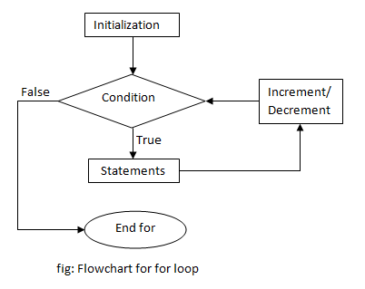

**Syntax:**

fun main(args: Array<String>) {

for (i in 1..5) {

println(i)

}

}

Output:

1

2

3

4

5

Department of Computer Engineering & Science.

**Do while flow chart**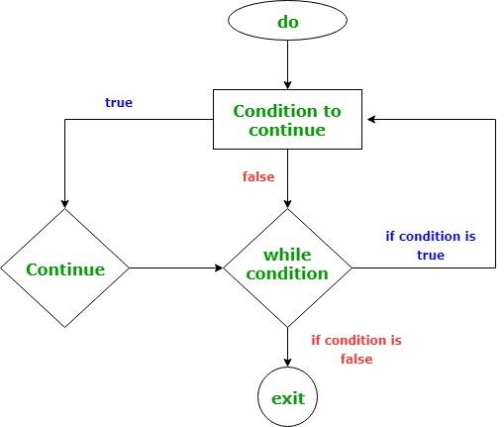

**Department of Computer Engineering & Application**

**Syntax:**

fun main(args: Array<String>) {

var sum: Int = 0

var input: String

do {

print("Enter an integer: ")

sum += input.toInt()

} while (input != "0")

println("sum = $sum")

}

Output:

Enter an integer: 4

Enter an integer: 3

Enter an integer: 2

Enter an integer: -6

Enter an integer: 0

sum = 3

**Error** An error is a service problem that does not let a program run.

**Exception**

An exception indicates condition that may or may not let the program run, based on

the execution of the program.

**Null pointer Exception**

A null pointer exception occurs when the compiler expects a value for variables but

instead gets null (no value).

A null safety operator is used to declare a variable whose value may be null.

Department of Computer Science & Engineering(CSE).

**Android Kick-Off**

**Activity**

An activity is a screen on your devices, which consist of the user interface. An

activity provides the window in which the app draw it‟s UI.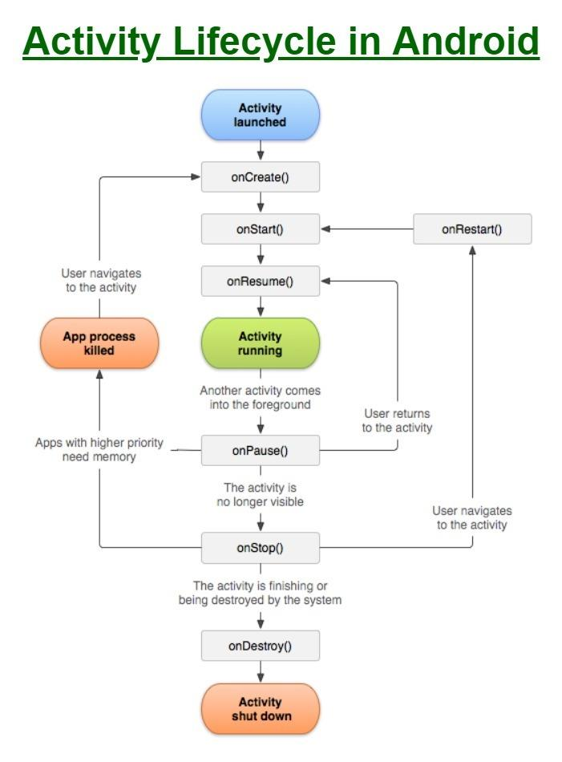

**XML**

**User Interface:** User interface is means by which the user and the system interact.

We need a UI so that the user can interact with the app and get some task done.

Creating a UI will also include formatting it, adding colours, buttons, margins, using

proper fonts, etc. All this is very important since it make it easy for the user to

identify the elements in the interface, their hierarchy, their purpose, etc.

**Layout:** A layout defines the structure in which the various elements on the screen or

the activity will be arranged.

All the elements in a layout are built using a hierarchy os view and viewgroup objects.

**Types:**

• Linear Layout

• Relative Layout

• Constraint Layout

**Pixel Density:** Pixel Density is the number of pixels present per unit of the screen.

**Database**

**Intent:** Intent is an object that provides runtime binding between separates

components, such as two activities. In simple terms, it creates a bridge between two

activities.

**Database:** when we want to store large amounts of data. The database can be

maintained on a database server which is connected to the internet, or it can be

maintained as a local database on user‟s device.

**Shared Preferences:** when we want to stores small amount of data. Data stored in

shared preferences is stored in our devices.

**Higher Order functionalities**

**Navigation View**

**ViewGroups:**

• **Linear Layout**

• **Relative Layout**

• **Scroll view**

• **Drawer Layout**

**Coordinator Layout:** A coordinator layout is a super-powered frame layout which is

used when there are multiple interactions between the views. For example, in our

situation, we will use it to manage the interactions between the navigation drawer,

toolbar and the frame layout.

**Hamburger icon:** The hamburger icon is known as the action bar drawer toggle. It

used to open and close the navigation drawer.

**Fragments**

They take up lesser RAM than an activity. Hence, the app works faster with fragments

than the activities. They are reusable across multiple activities.

A fragment is a modular section of a activity, which has its own lifecycle, receives its

own user inputs due to the user interacting independently with it.

We can also reuse fragments in multiple activities.

**Fragment transaction:** Any action that we perform to open or close a fragment is

known as fragment transaction. Each fragment transaction is stored inside a back

stack, which is maintained by the activity.

**Need of back stack:** The reason a back stack is maintained is because it allows us to

reverse a fragment transaction. That is, we can navigate back to a fragment

**Department of Computer Science & Engineering(CSE)**

**Understanding Fragment**

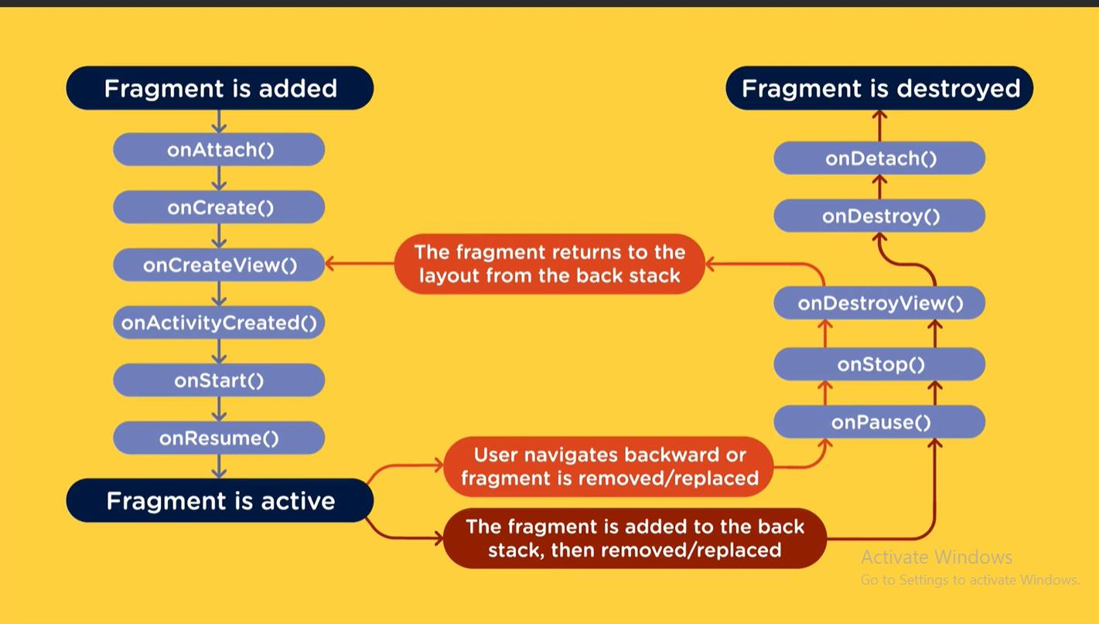

**AppBarLayout:** An AppBarLayout is a vertical Linear Layout which implements

many of the features of material design app bar concept, namely scrolling gestures.

This view depends heavily on being used as a direct child within a Coordinator

layout. If you use AppBarLayout within a different view group, most of its

functionality will not work

Department of Computer Science & Engineering(CSE).

**Layout Manager:** The Layout Manager is responsible for displaying the items of the

list in a set pattern.

• Linear Layout Manager

• Grid Layout Manager

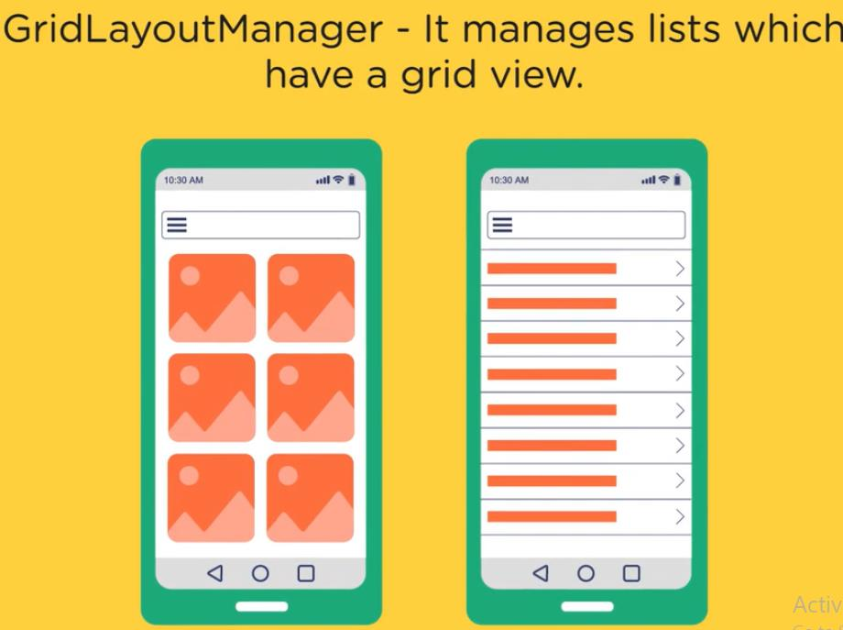

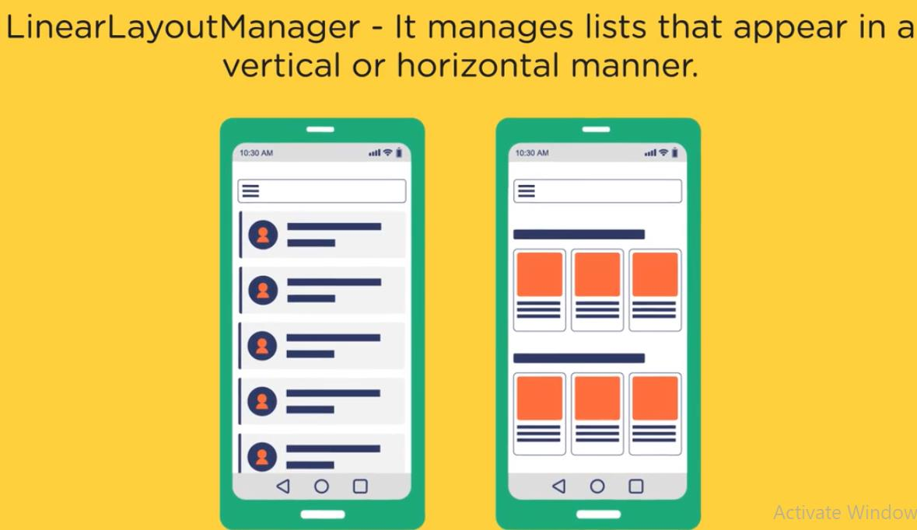

Department of Computer Science & Engineering(CSE)

**Adapter:** The Adapter is responsible for creating the view that the view holder holds.

It also binds the view with the data.

It assigns positions to different rows and uses the positions to assign data to different

rows.

The adapter serves as a bridge between data and the view.

**View Holder:** View holder does not need to be created of inflated, instead, the app

just updates the view‟ contents to match the new item that the viewholder is bound to.

**Network request:** A network request is a request made by our devices to the server.

These two are connected in a network.

**Types:**

• **GET request:** Request using the GET method are used when we want to

retrieve data and not make any changes to any other data on the server.

• **POST request:** Request using the POST method are used when we want to

send data

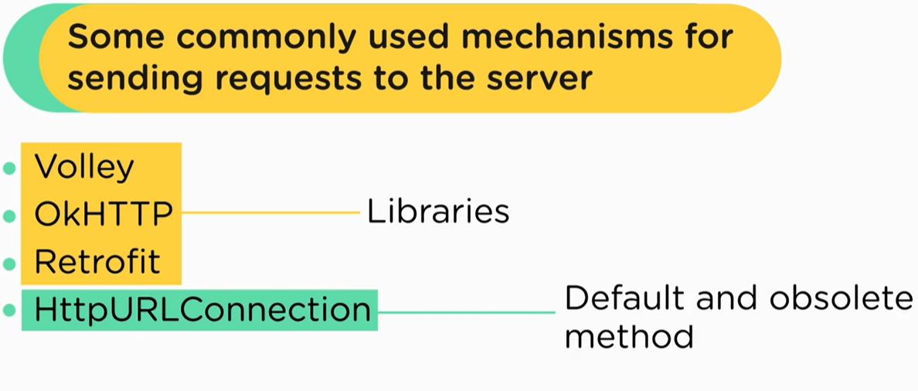

Following Screenshots of the project

**Main Activity**

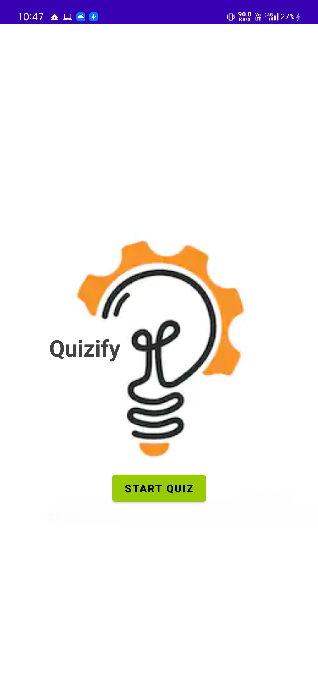

**Department of Computer Science & Engineering(CSE).**

**Subject Categories**

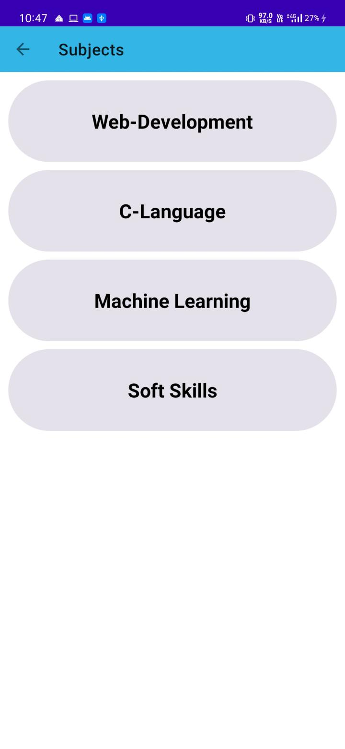

**Set of Question**

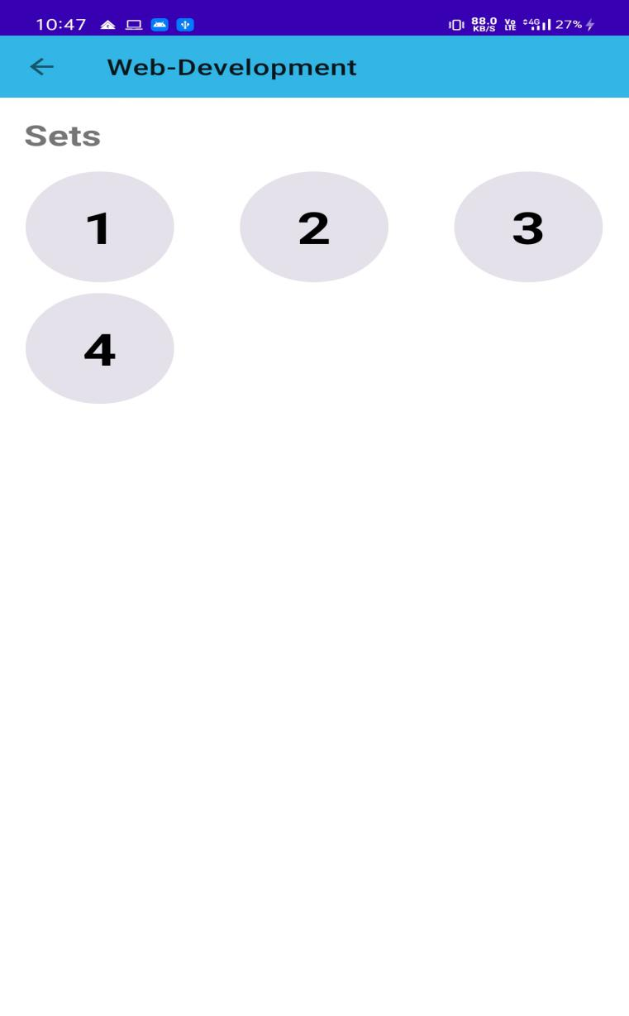

**Questions UI**

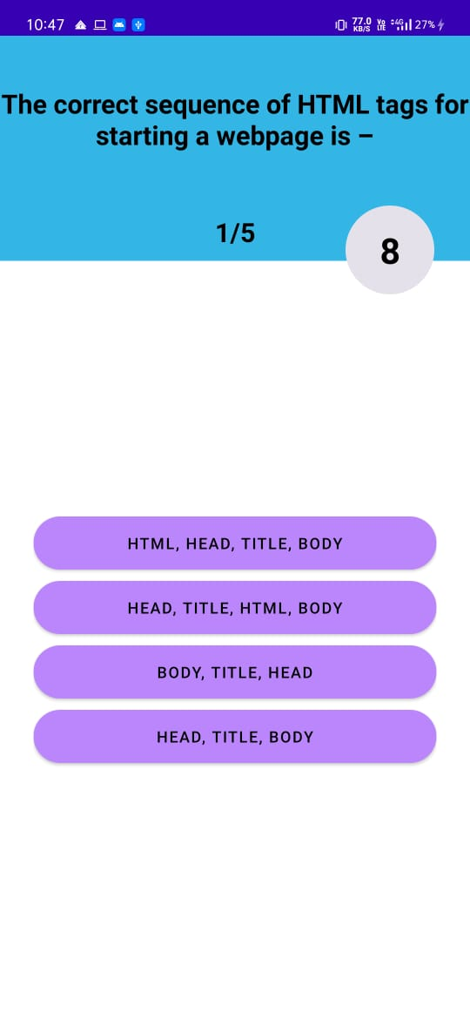

Department of Computer Science & Engineering(CSE).

**Result Page**

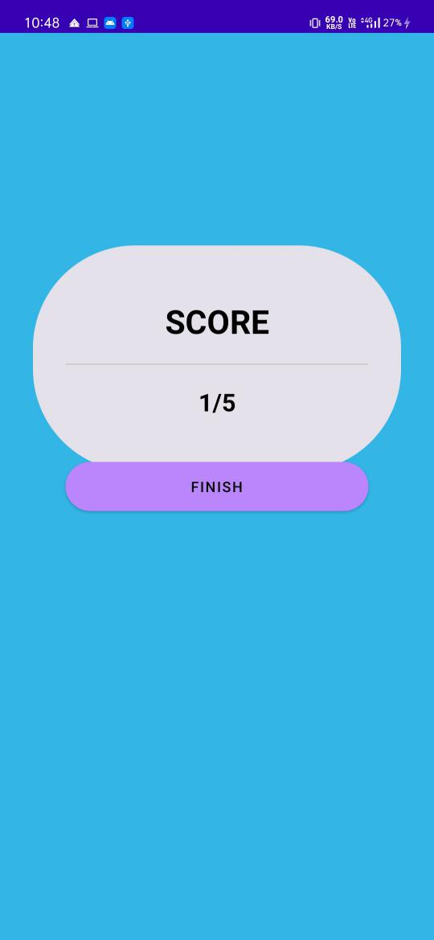

Department of Computer Science & Engineering(CSE).